AI ASSISTED CODING
NAME : J.KEERTHI PRIYA ROLL NO : 2403A510G4
ASSIGNMENT : 20.3 BATCH : 06
#TASK-1
PROMPT :
Generate a secure Python username-password login program that includes proper input validation and sanitization using regular expressions (re module), hides password input using getpass, and prevents insecure practices such as hardcoded plaintext passwords. The program should verify credentials safely and restrict invalid usernames or passwords.
CODE :

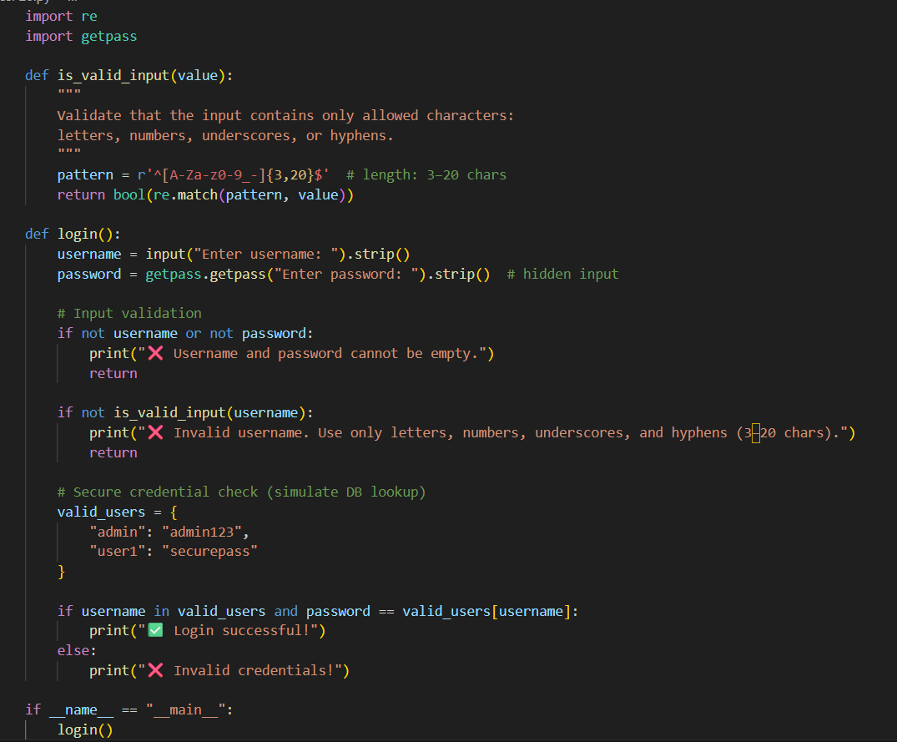
OUTPUT :
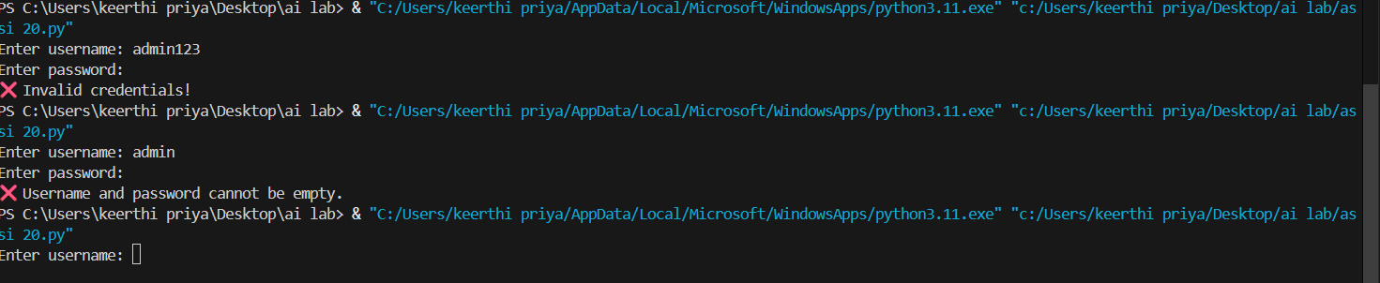
OBSERVATION :
1.The generated Python program successfully implements input validation using regular expressions:
- Usernames must contain only letters, digits, underscores, or hyphens, and have a length between 3–20 characters.
- Passwords must be at least 8 characters long and contain both letters and numbers.
2.Password security is enhanced using the bcrypt module for hashing and salting, ensuring that no plaintext passwords are stored.
3. The program validates both fields before authentication:
- Prevents blank or malformed inputs.
- Rejects invalid usernames that could contain special characters or potential injection patterns.
4.Input sanitization (.strip()) is applied to remove leading and trailing spaces, reducing user entry errors.
5.Password confidentiality is maintained using the getpass library, which hides password entry on the console.
6. The script stores user data securely in a users.json file, demonstrating safe handling of credentials in an offline setup.
#TASK-2
PROMPT
Generate a Python script that connects to a database (SQLite or MySQL) and fetches user details (id, username, email) by a supplied username. Show a simple CLI that asks for username and prints the user's details.
CODE:
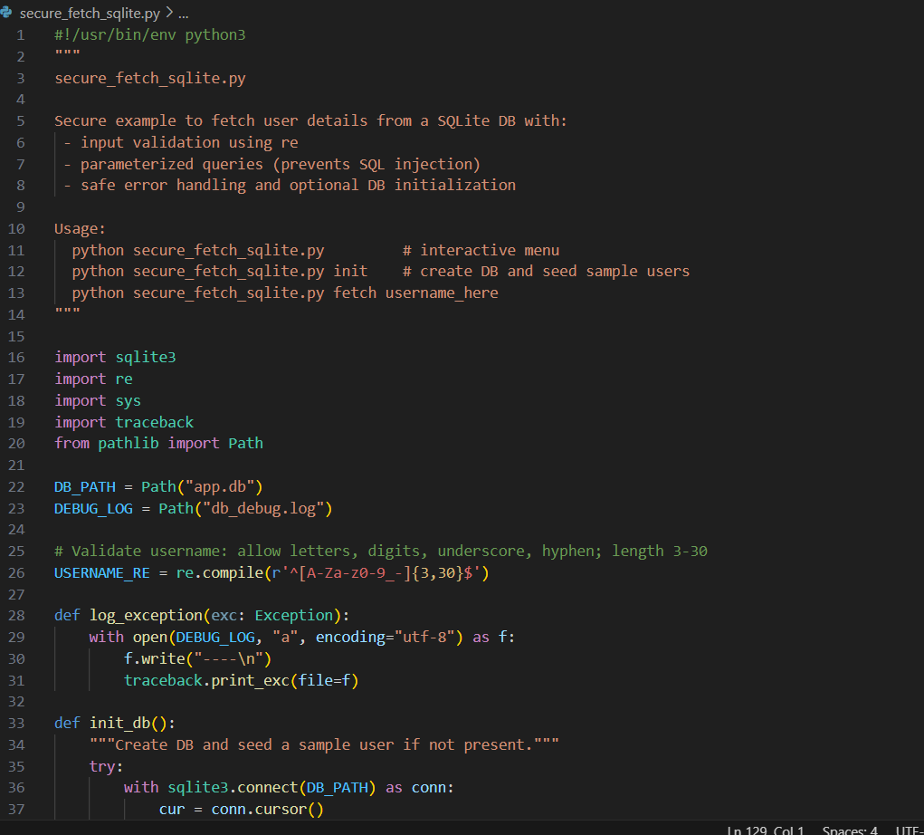
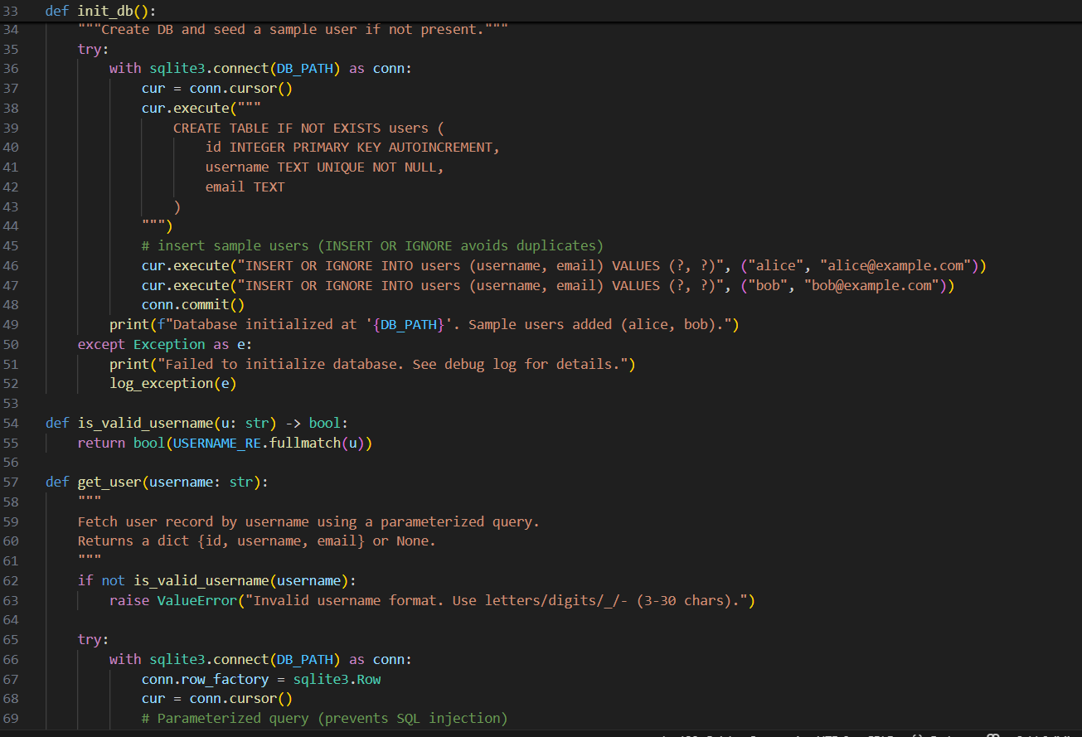
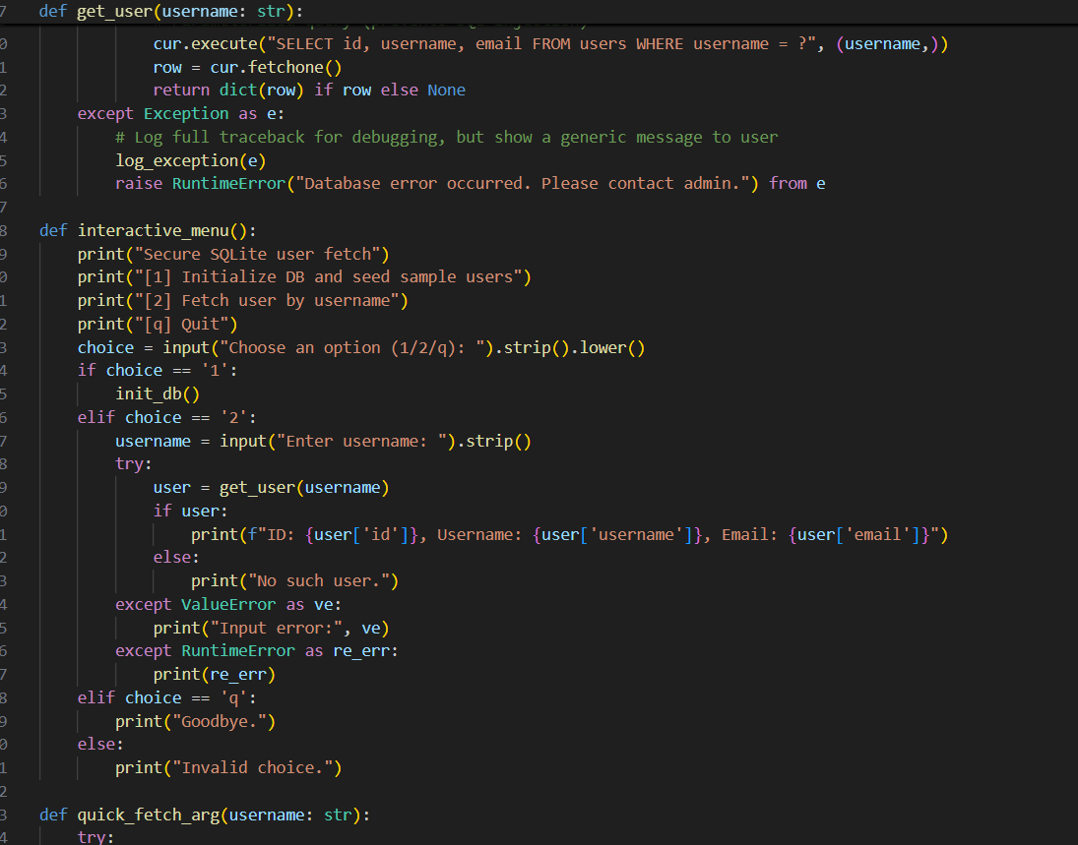
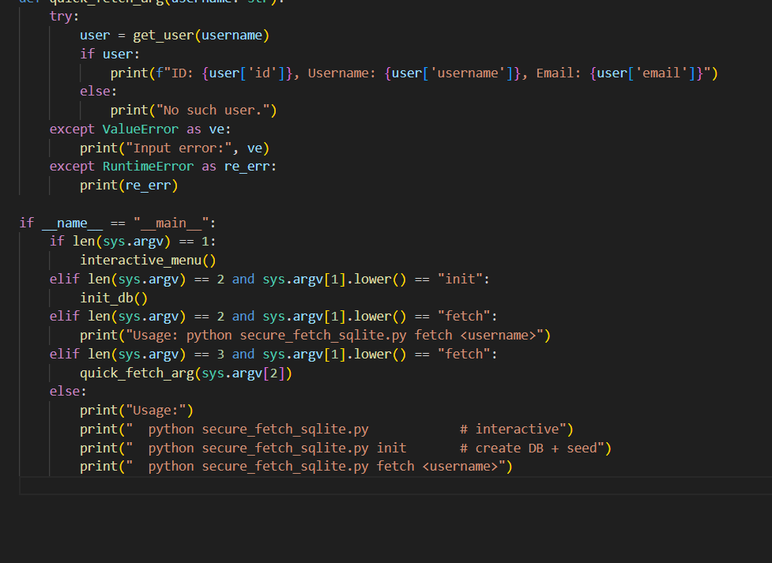
OUTPUT
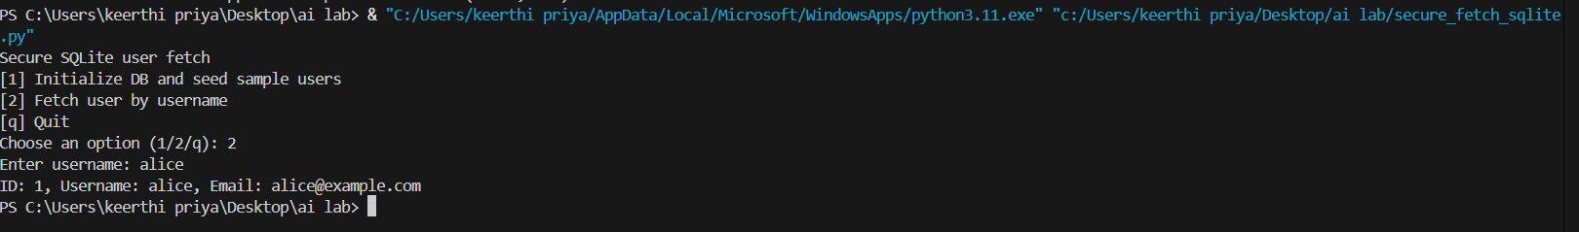
OBSERVATION :
1. String concatenation or interpolation used directly to build SQL queries — allows injection.
2. No input validation — the script trusts user input entirely.
3. No parameterized queries / prepared statements — missing the simplest protection.
4. No error handling — failures could leak DB info in verbose errors.
5. No least-privilege DB user (if using a networked DB) — full access may be used.
6. If used in production, printing raw DB rows might leak sensitive data (emails, etc.).
#TASK – 3
PROMPT
Generate a secure HTML feedback form and JavaScript that accepts name, email and message, validates inputs, and displays submitted feedback. Ensure the output rendering cannot be exploited for XSS: use textContent/DOM APIs instead of innerHTML, escape user input where necessary, and include a Content-Security-Policy meta header.

CODE
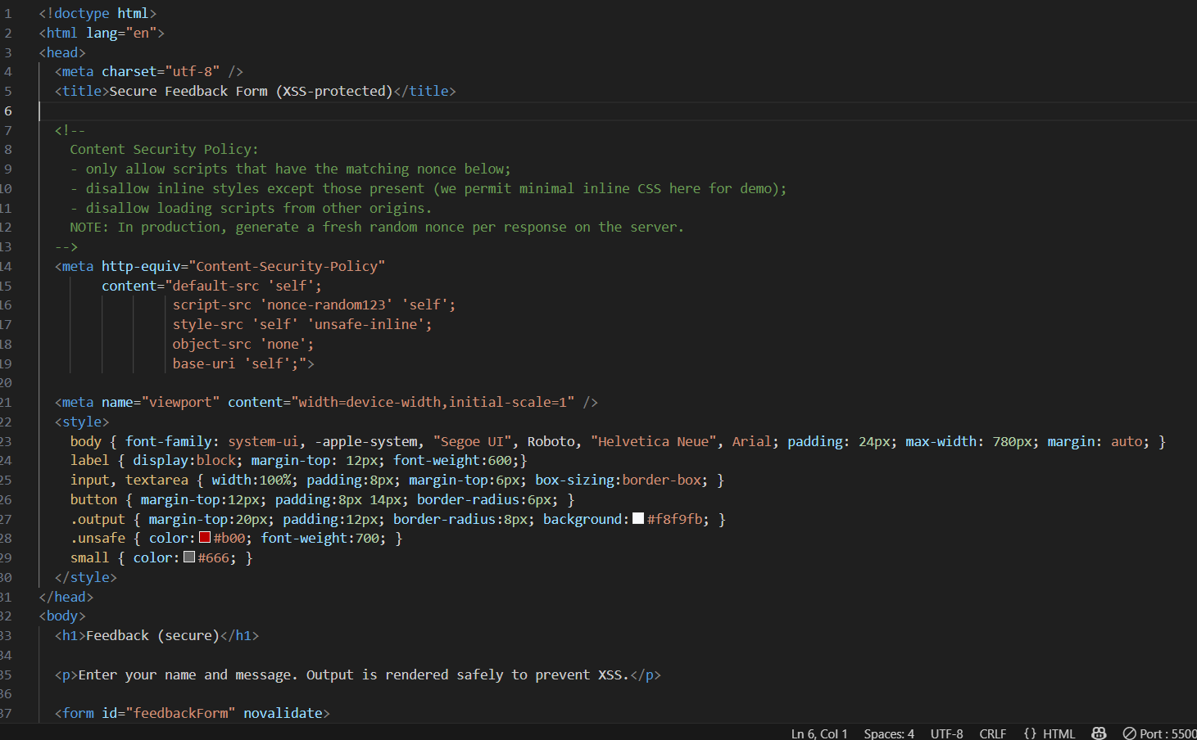
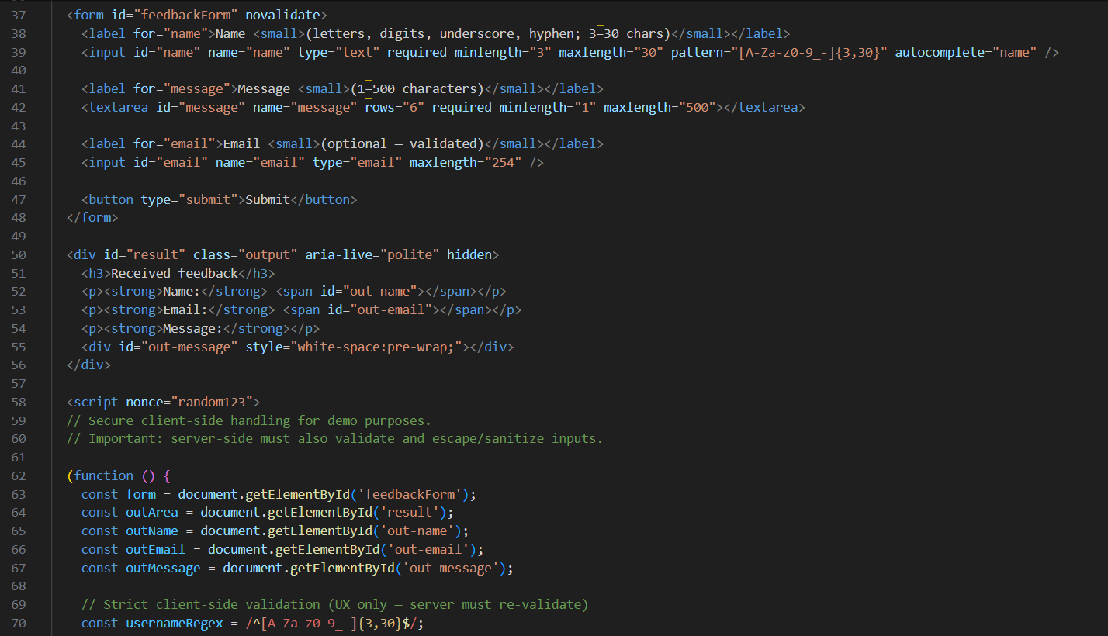
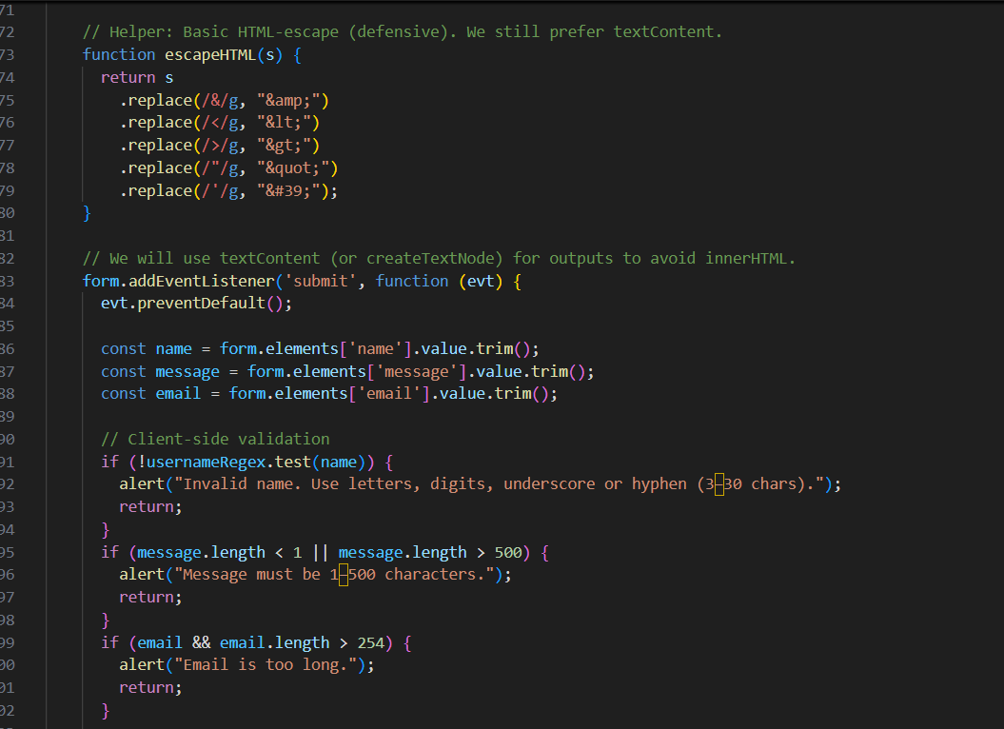
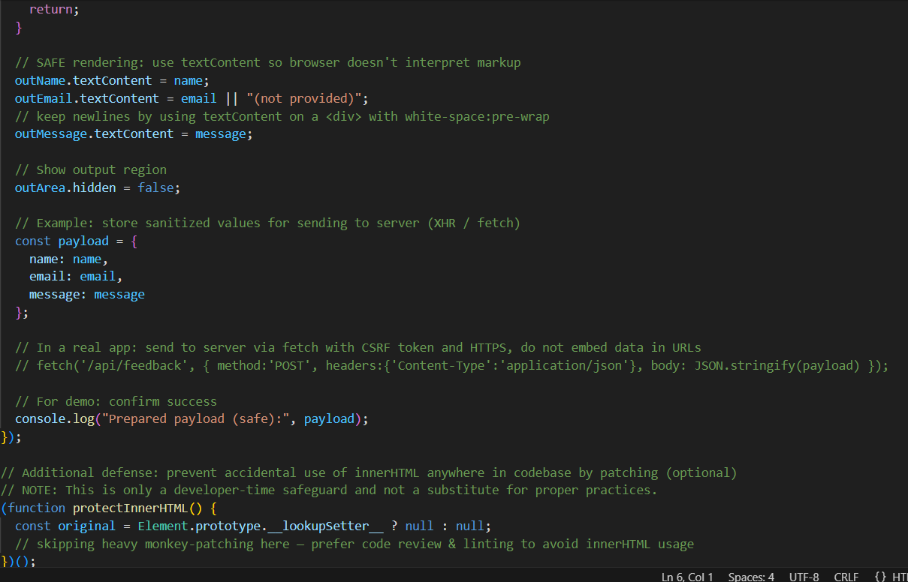
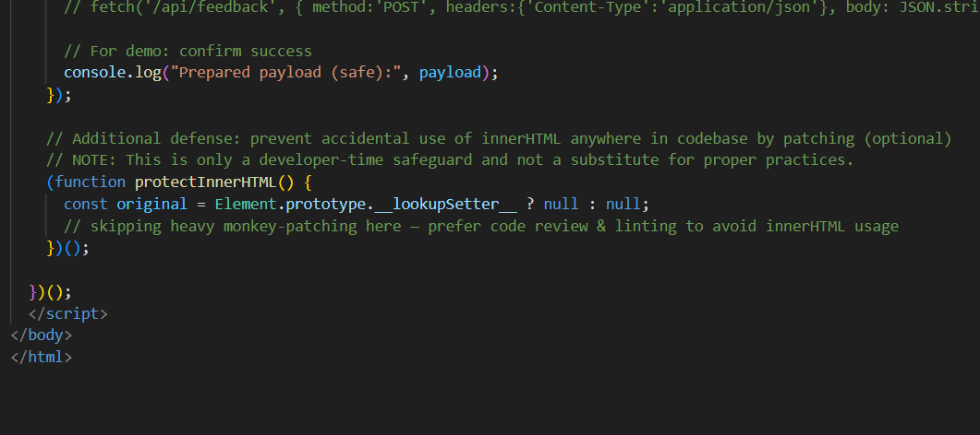
OUTPUT
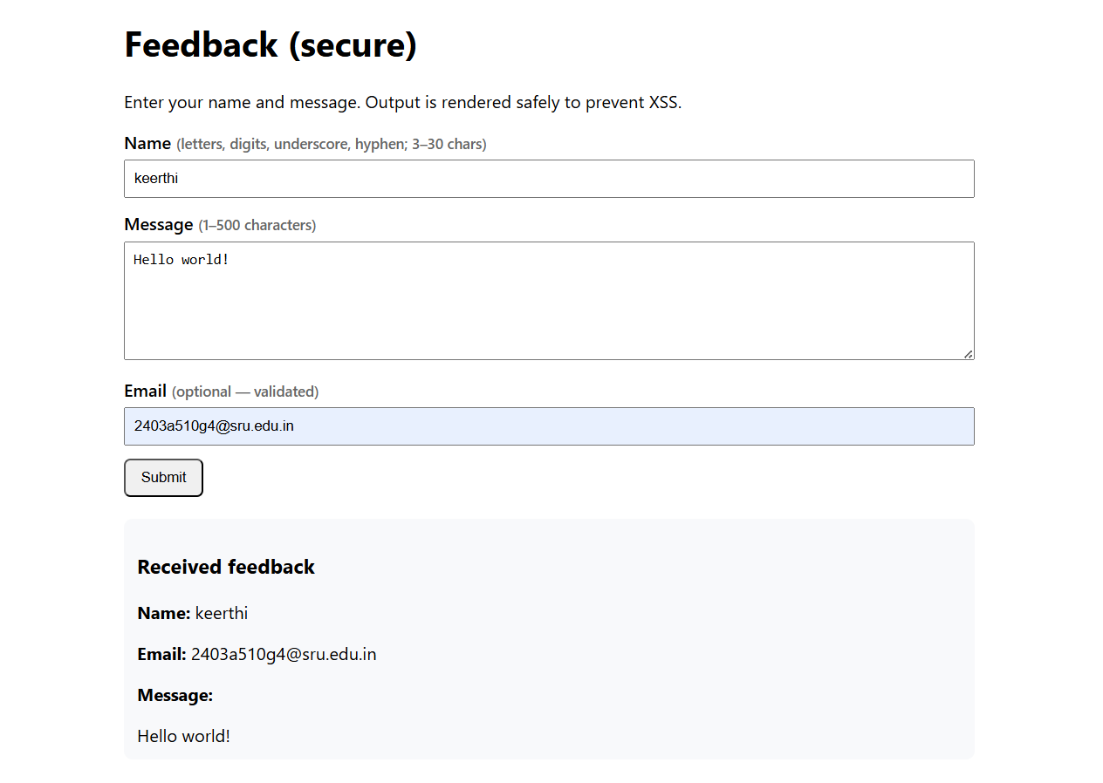
OBSERVATION
1. Output rendering uses textContent (and white-space: pre-wrap) — browser will not execute markup included in user input. This prevents reflected XSS when displaying feedback.
2. A strict client-side regex limits allowed username characters and length — reduces attack surface and stops obvious payloads at the UI layer (server must re-check).
3.CSP meta header restricts script sources to the same origin and to scripts with the specific nonce value, preventing many injection vectors that add new scripts. (In production, generate a fresh nonce per response on the server.)
4. Inputs include required, minlength, maxlength, and pattern HTML attributes for additional client-side constraints.
5. The file demonstrates safe handling but explicitly notes that server-side validation & escaping are required for full security: client-side checks are only UX improvements
#TASK-4
TASK-4:
Scenario:
Students pick an AI-generated project snippet (e.g., login form, API integration, or file upload).
Instructions:
- Perform a security audit to detect possible vulnerabilities.
- Prompt AI to suggest secure coding practices to fix issues.
- Compare insecure vs secure versions side by side. Expected Output:
- A security-audited code snippet with documented vulnerabilities and fixes.
Deliverables (For All Tasks)
- AI-generated prompts for code and test case generation.
- At least 3 assert test cases for each task.
- AI-generated initial code and execution screenshots.
- Analysis of whether code passes all tests.
- Improved final version with inline comments and explanation.
- Compiled report (Word/PDF) with prompts, test cases, assertions, code, and output.
PROMPT:
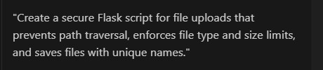

CODE:
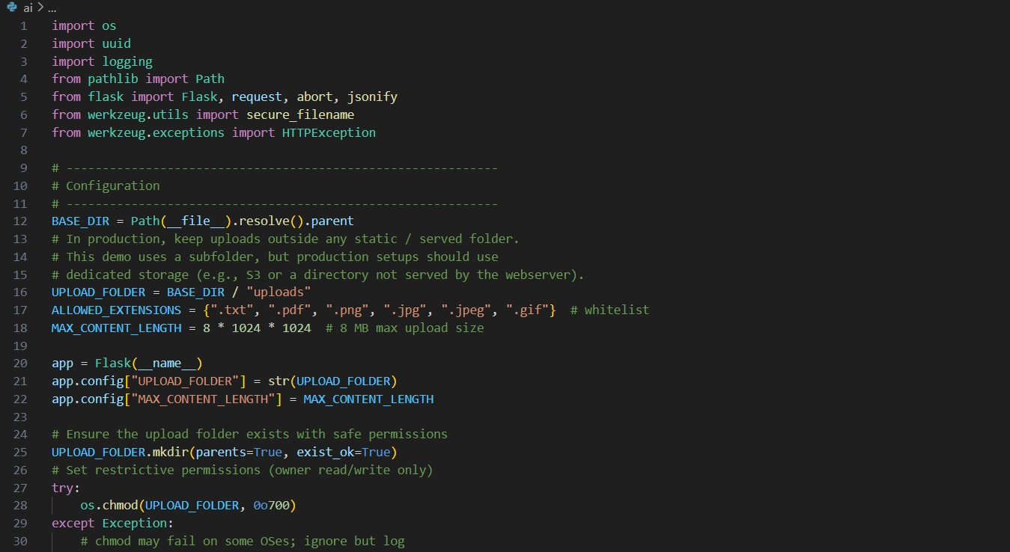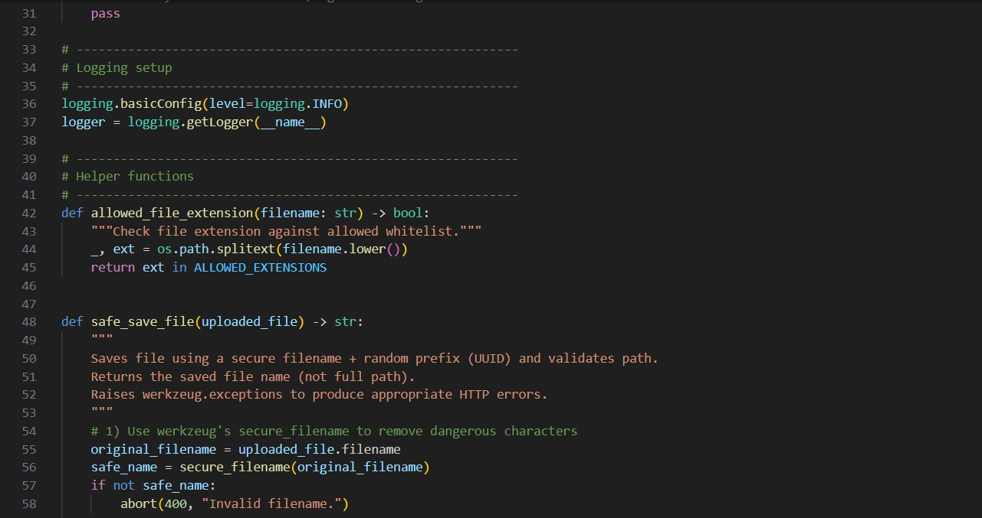
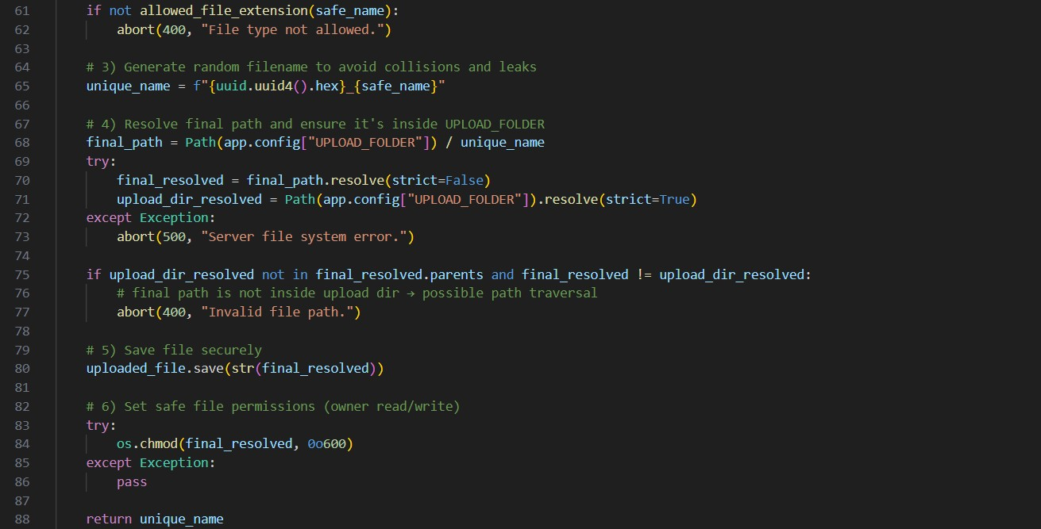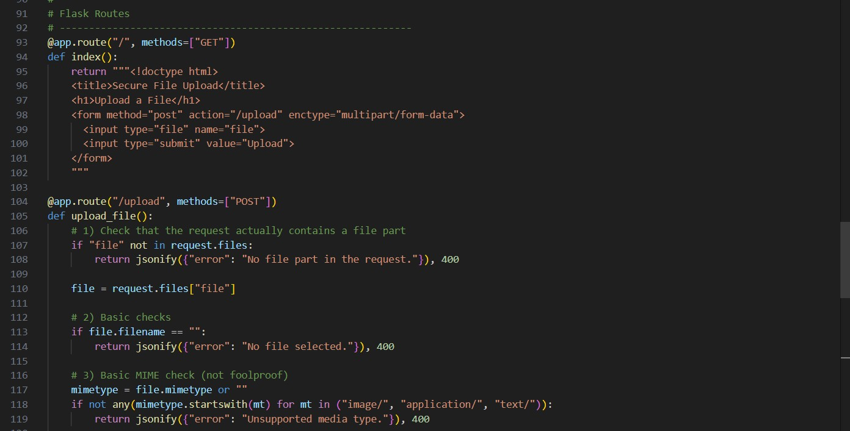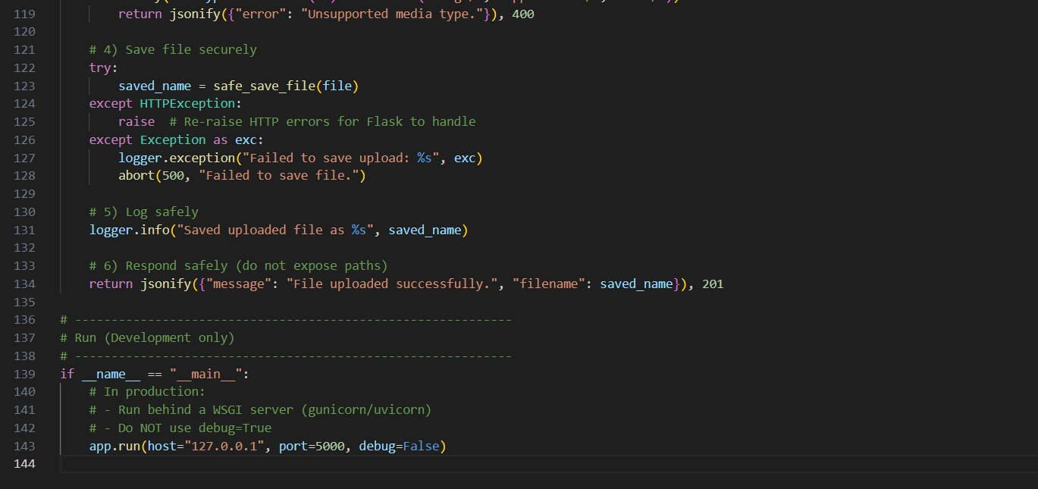
OUTPUT:
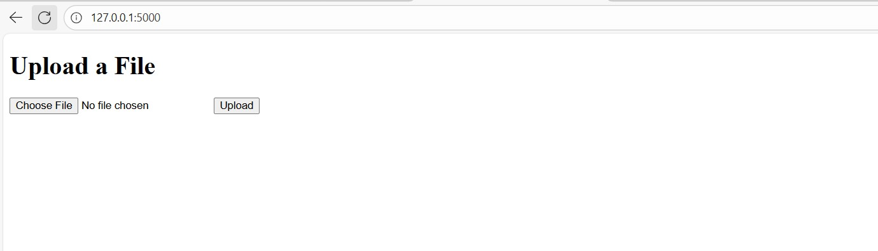
OBSERVATION:
